Unit 8 Day 1:Periodic Data, The Unit Circle, and Radian/Degree Measure Name: ________________________

Periodic Functions

A periodic function is a function that repeats a pattern of ________________ (or outputs) at regular intervals.
One complete pattern is a _________________. A cycle may begin at any point on the graph of a function.
The time it takes for a cycle to repeat is called the ____________________.
The amplitude of a periodic function measures the amount of _________________ (up and down) in the function values.

The amplitude can be found using the formula:

Example: What is the amplitude of the function below? You Try! What is the amplitude of each periodic function?

Radians vs. Degrees

A degree is the amount of _____________________ around a circle (used in geometry and real-world applications)

A radian is the measure of the ___________. (Think: circumference = ____________) You can switch between using degrees and radians.

Converting between Degrees and Radians

To convert FROM… | TO…
Degrees | Radians
Radians | Degrees

Note: Radians must always be in _________ form. Degrees must always be in _________ form.
Convert from… | To… | Formula | Answer
90° | Radians
$\frac{7π}{6}$ radians | Degrees
200° | Radians
$\frac{5π}{4}$radians | Degrees
-150° | Radians
5 radians | Degrees
540° | Radians
$\frac{7π}{8}$radians | Degrees
$\frac{6π}{7}$radians | Degrees
52° | Radians

The Unit Circle

A full rotation around a circle totals _____________ degrees, which is the same as____________ radians.
Multiples of 45° Multiples of 30°

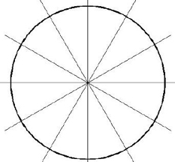

The symbol used for an unknown angle is called ______________ it looks like this: Ѳ
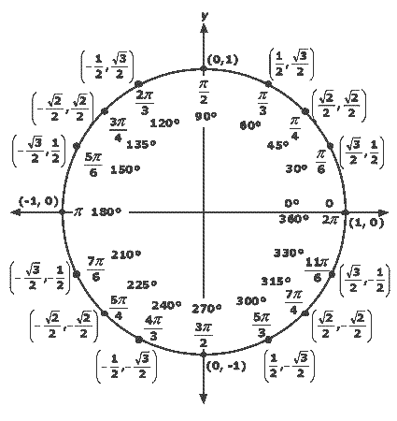
Instead of creating a _____________________ and doing “SOHCAHTOA” to find the sine, cosine or tangent, you can use the unit circle to look up the values quickly. Just remember that cos(Ѳ) = _______ and sine(Ѳ) = _________.

- x-value of the coordinate= ____________ of that angle

- y value of the coordinate=_____________ of that angle

- $\frac{y-value}{x-value}$ = the _________________ of that angle

Positive angle move ___________________________

Negative angle move___________________________

- cos(45°)
- sin(120°)
- cos(180°)
- tan(315°)

- $\cos\left(\frac{π}{6}\right)$
- $\sin\left(\frac{4π}{3}\right)$
- $\cos\left(\frac{3π}{4}\right)$
- $\tan\left(\frac{7π}{4}\right)$

- cos(-45)°

- sin(-120°)

- tan(180)°

- cos(-315°)

