Unit 8: Graphs of Trigonometric Functions Name: ____________________________________________
Ѳ | cos(Ѳ) |  | Ѳ | sin(Ѳ)
0 |  |  | 0
$$\frac{π}{3}$$ |  |  | $$\frac{π}{6}$$
$$\frac{π}{2}$$ |  |  | $$\frac{π}{2}$$
$$\frac{2π}{3}$$ |  |  | $$\frac{5π}{6}$$
$$π$$ |  |  | $$π$$
$$\frac{4π}{3}$$ |  |  | $$\frac{7π}{6}$$
$$\frac{3π}{2}$$ |  |  | $$\frac{3π}{2}$$
$$\frac{5π}{3}$$ |  |  | $$\frac{11π}{6}$$
$$2π$$ |  |  | $$2π$$

Graph of “Cosine”

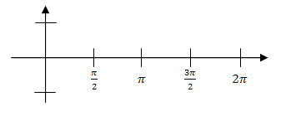
1
0.5
-0.5
-1

1
0.5
-0.5
-1

Graph of “Sine”

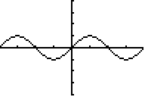

Graphing in the Calculator:
1. Calculator needs to be in _________________ mode
2. Use “x” for Ѳ
3. Zoom ___________

Transformations of sine & cosine
Describe the transformations that took place, then sketch their graphs on the graph of the parent function below
a. $f\left(x\right)=2\sin\left(x-\frac{π}{2}\right)$ b. $f\left(x\right)=\cos\left(x+π\right)-1$ c.$f\left(x\right)=-4\sin\left(x\right)$

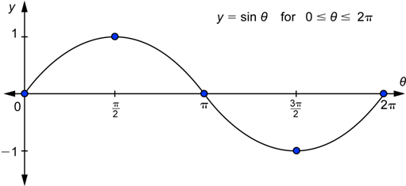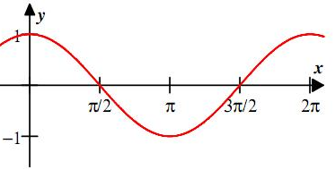

$y=asin⁡(bθ)$ or $y=acos⁡(bθ)$
Amplitude: half the height of the graph

Cycle: One complete pattern in a graph

Period: How long it takes to complete a cycle

- ______ is the amplitude of the function
- ______ is the number of cycles in the interval from ____________
- __________ is the period of the function.
Example 1: Find the period and amplitude of each function below

a. b. $f\left(x\right)=4\sin\left(x\right)-1$ c. $f\left(x\right)=\cos\left(2x\right)$

Amplitude: _________ Amplitude: _________ Amplitude: _________

Period: ___________ Period: ___________ Period: ___________

- Given: $y=3cos2θ$  - What is the amplitude of the function?__________  - What is the period of this function?____________ | - Given: $y=-\frac{1}{2}sin4θ$  - What is the amplitude of the function?_____  - What is the period of this function?_______
- Given: $y=1.5cos3θ$  - What is the amplitude of the function?__________  - What is the period of this function?_____________ | - Given: $y=0.5sin\frac{π}{3}θ$  - What is the amplitude of the function?_____  - What is the period of this function?______________________

Example 2: Write the function and sketch the curve of the sine function with the following description: amplitude of 2 and period of $\frac{π}{2}$

You Try: Write the function and sketch the curve of the cosine function with the following description: amplitude of 4 and period of $4π$

- Write sine function with the following description: Amplitude of 1 and period of $\frac{π}{4}$

- Write the cosine function with the following description: Amplitude of $\frac{π}{6}$ and period of 6

