**Practice: Holes & Asymptotes**

**Name: ___________________________________________________**

Describe the graph of each rational function and use a highlighter to identify the holes & asymptotes

1. $f\left(x\right)=\frac{1}{x+5}$

Hole(s):

Asymptotes:

Domain:

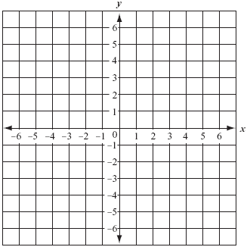

2. $f\left(x\right)=\frac{x-2}{x^{2}+2x-8}$

Hole(s):

Asymptotes:

Domain:



3. 

Hole(s):

Asymptotes:

Domain:



4. $f\left(x\right)=\frac{x^{2}+5x+4}{x^{2}+8x+16}$

Hole(s):

Asymptotes:

Domain:



5. $f\left(x\right)=\frac{4x+5}{x+2}$

Hole(s):

Asymptotes:

Domain:



6. $f\left(x\right)=\frac{x-1}{x^{2}-x-6}$

Hole(s):

Asymptotes:

Domain:

